Jeziel E. Torres Vazquez

INEL 4998 (Investigation Course)

Prof. Eduardo Ortiz

Week: January 11-15

Hello, my name is Jeziel Torres, I study Computer Engineering. Solar Energy is important to me. The world is changing and the more the way we generate energy has to change to make a better world for our future. The petrol and smoke are damaging our planet and we must make a difference to protect it. That is why I am really intrigued about solar energy and renewable energy in general. Making a change to make a better world for our future and move to more advanced ways of generating energy to the whole world.

I was very interested in this course of investigation because renewable energy has become one of my passions over the years. After Hurricane Maria passed through Puerto Rico, I lost energy in my house like all Puerto Ricans living in the island. After some months my family and I were exhausted to work with a generator. We found someone that knows how to install a solar system. He came to our house and taught us how it works. From that day we have solar energy in our house and now we run 24/7 solar on our house.

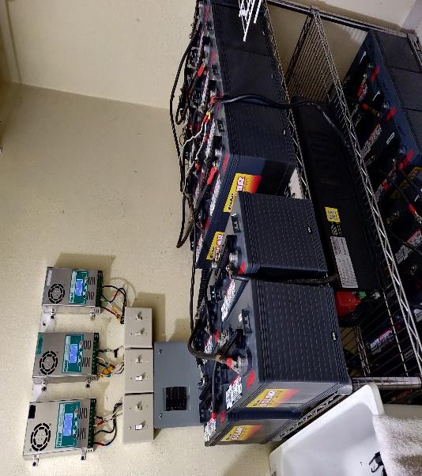



In this week I had my very first reunion with the full team. They explain everything they were doing and what was the status of the project. Cristian did a meeting with all the new members to accommodate us in our respected teams and told us a little bit of what we were going to be doing in our assigned area. My assigned area is with the Impact Distribution System Analysis. In this area we work with a coding tool called OpenDss that helps to simulate the circuit that we want to build and see how its performance with all the components. It tells us if there is a system overload or some components does not work well with the system. We work with the parameters and design the Design Team's hands to us so we can create, simulate, and investigate if the circuit is working properly or needs modifications.

In this first week Cristian told us to read the Master Plan for Denver and Auraria Campus and the rules of the competition. This is because the competition was running last semester and the new recruits, like me, entered a semester late. I read all the documents and ask the important question to be at time with the investigation. I communicated with Angel and Juan, fellow members of the OpenDss Team, to make reunion and see what my task is going to be and how I could help the team.